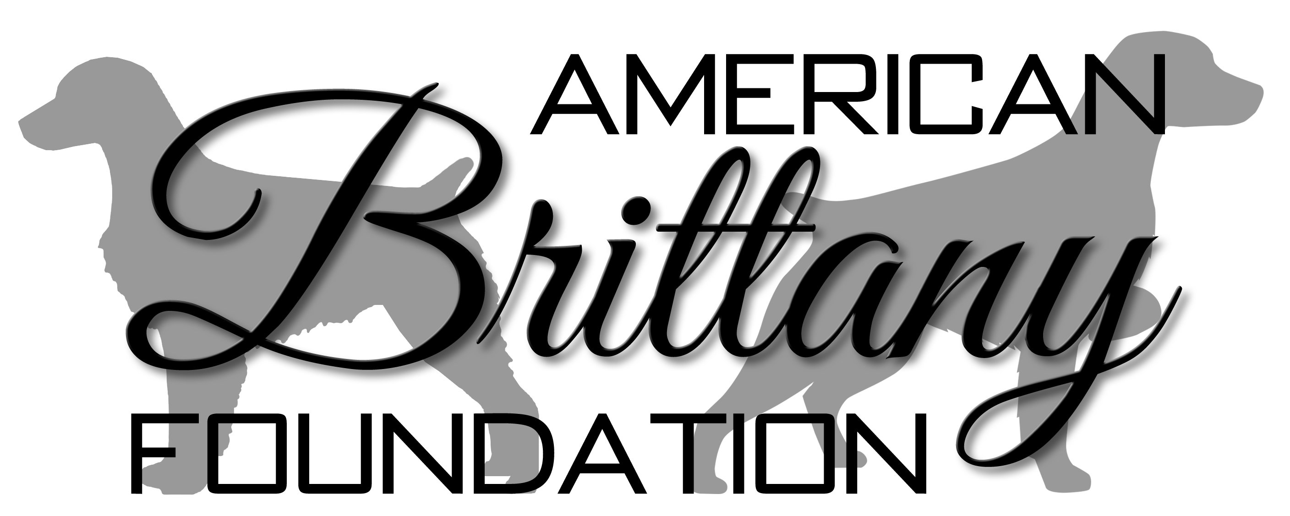

DONATION FORM

Donations can be made to the American Brittany Foundation by Check.
A gift receipt will be sent to you for your donation.

Please print and complete the form below and include with your check

Donation Type: General To be used for:

Date:

I am enclosing a donation in the amount of: $

Donated by
Name(s):

Address:

City, State, Zip:

Phone, Email Address (optional):

I request my donation remain anonymous.

Please make check payable to:
Please make check payable to:
American Brittany Foundation
2 Doe Drive
Franklin MA 02038
For more information contact:
AmericanBrittanyFoundation@TheAmericanBrittanyClub.org
774-686-1680

American Brittany Foundation is a tax exempt 501(c)(3) corporation.
Your contribution is tax deductible to the extent provided by law.

