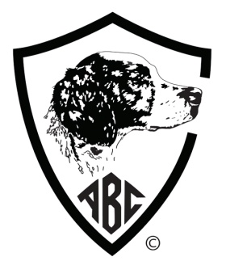 | Final Forfeit for the 2019/2021  The American Brittany Club, Inc.  73ndField Futurity ~ 58th Show Futurity  FINAL FORFEITS CLOSE OCTOBER 1, 2020  Open to all Brittanys from enrolled litters.  Dogs must be owned by ABC members or members of their immediate family.
SECTION |  | EASTERN | CENTRAL | WESTERN | Note: Entries postmarked AFTER Oct 1  are required to pay an additional  $50 late fee for each box checked.  No Forfeit will be accepted after Dec 31, 2020
Field Forfeit ($30.00 per section)
Show Forfeit ($30.00 per section)

Full Name of Dog: |  |  | AKC DNA (optional)
AKC # OTHER | FDSB # | Date of Birth: | Sex: |  | Color:
Name of Breeder (s):

Sire:

Dam:

Owner (s):
Address:
City: |  | State: | Zip:
Email Address: |  |  |  | Telephone:
ABC Club: |  |  | Exp:
I (we) certify and represent that the information contained in this Futurity Forfeit is true and correct to the best of my (our) knowledge. I (we) agree to comply with the ABC Futurity rules and regulations and I (we) are in good standing with the ABC.
Signature of owner:
Winnings, if any, will be paid ONLY to the Primary Owner of record as shown on the final entry form for each event

mail check with entry to
Jacqui Campbell, Futurity Secretary
19721 133rd Ave. SE, Snohomish, WA 98296
E-mail: campbellsbrittanys@gmail.com Phone: 425-308-0750

Make checks payable to : AMERICAN BRITTANY CLUB

FOR OFFICE USE ONLY Date Postmarked:____________________ Fee Received:______________ Check No:___________

