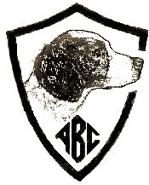
PREMIUM LIST
ABC Western Futurity
Thursday and Friday, April 4 - 5, 2019
Hosted by the Oregon Brittany Club

Dear Futurity Participant:
Enclosed please find the Western Section Entry Form(s) for your 2019 eligible futurity dog (s). This entry blank is being sent to you because of your 2017 breeder’s nomination and your final forfeit payment paid in 2018.
When completing your entry form, PLEASE PRINT CLEARLY.
Send your entry form and check, payable to the “American Brittany Club” to:
Jim Hammett, ABC Western Section Secretary
57758 Childress Loop
John Day, OR 97845
(541) 932-4860
EMAIL: jhammet@ortelco.net (note only 1 ‘t’ in the email address)

CLOSING DATE: Thursday, March 28, 2019 at 6:00 PM (Pacific)
DRAWING DATE: Saturday March 30, 2019 at 6:00 PM (Pacific)

For those dogs eligible for the field, you must now make the determination whether to enter the All Age or Gun Dog stakes. You may not enter both. Performance standards for the field are on this premium. ENTRY FORMS AND PAYMENT ARE EXPECTED PRIOR TO THE CLOSE OF THIS EVENT.
Prize money will be paid to both the breeder and owner of record as identified on this entry blank. If you have sold your futurity nominated dog since paying the final forfeit last year, please pass this premium on to the new owner.
Information from the Oregon Brittany Club is also enclosed. Note directions & lodging info are also on this premium.
Good luck in the upcoming competition.
Sincerely,
Linda Langford
ABC Futurity Secretary
lalangford@hotmail.com
(205) 790-2133

ORDER OF EVENTS AND JUDGES

Thursday, April 4, 2019 Futurity Field All Age Event, 7:30 AM
Judges: John Henderson (WA) & Larry Sandusky, (ID)
Futurity Field Gun Dog Event will follow
Judges: John Henderson (WA) & Larry Sandusky, (ID)

Boyce Corral, Madras, Oregon

Friday, April 5, 2019 Futurity Show Event
Judge: Robin Tomasi (ID)
Erickson Aircraft Museum (indoors)
2408 NW Berg Drive
Madras, OR 97741
Afternoon judging (estimated 2 PM)
Show site open at noon.
Actual show start time dependent on field events.
Lunch provided by the OBC prior to judging.
Ample parking at the show, but NO overnight parking.

Section Manager (Field): Section Manager (Show): Section Secretary:
Joe Waitman Dianne Kroll Jim Hammett
jwaitman@canby.com Dianne.kroll@frontier.com jhammet@ortelco.net
(503) 754-1273 (971) 221-7623 (541) 932-4860

American Brittany Club Officers
www.theamericanbrittanyclub.org
Ed Janulis President
Kent Patterson 1st Vice President
Jeri Conklin 2nd Vice President
Dawn Droel 3rd Vice President
Bob Burchett 4th Vice President
Keith Wolnewitz Treasurer
Jan Kilpatrick Secretary
7865 CR 271
Hico, TX 76457
254-485-0844
jankilabc@gmail.com Oregon Brittany Club Officers
https://www.facebook.com/oregonbrittanyclub
President Steve Cosgriff
Vice President (Field Trials) Jim Hammett
Vice President (Shows/Obedience) Diane Kroll
Secretary/Treasurer Mark Shearman

DIRECTIONS TO TRIAL GROUNDS

Boyce Corral – Crooked River National Grassland, USDA Forest Service

To Madras (North)
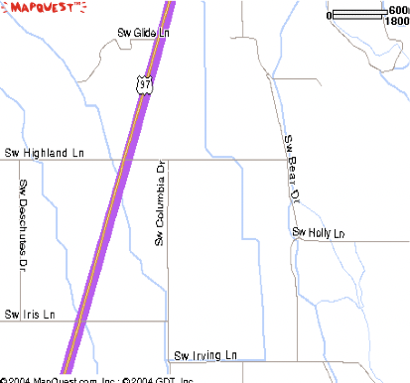
Turn Right Here
Follow Paved to Gravel Road.
Look for Corrals, Vehicles & Dogs
To Bend (South)

Turn east onto SW Highland Lane from HWY 97; continue east to a stop sign. Turn right (south) onto SW Bear Drive; follow road as it curves to the east, eventually turning into a gravel road (Holly Road). Proceed until you see the campground.

ROUTE TO SHOW SITE
Show site is at the north end of Madras, near the airport.
From Highway 26 (5th Street), turn East onto Cherry Lane. At the airport, bear right onto Berg Drive and proceed 1/10th mile up on Berg Drive.

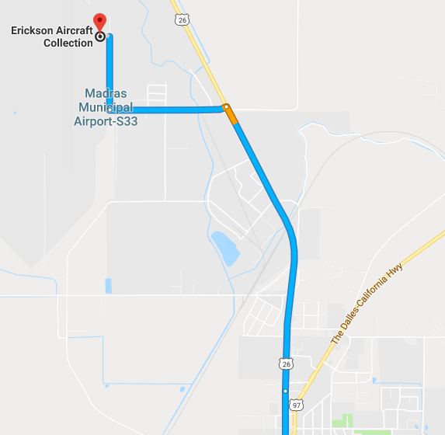

Oregon Brittany Club Field Trial, April 2 thru 7.
The Oregon Brittany Club, in cooperation with Crooked River National Grassland, USDA Forest Service (Permit FS-2700-4) is holding the
ABC Western Regional Futurity
in conjunction with the
Western Shooting Dog Championship, April 2-3 and the
Oregon Brittany Club Spring Field Trial April 5-7
Premiums for the trial will be available on the American Brittany Club website: www.theamericanbrittanyclub.org located in the index of club premiums.
Or, you can contact Field Trial Secretary Jim Hammett 57758 Childress Loop, John Day, OR 97845. Phone: (541) 932-4860 or email: jhammet@ortelco.net (note, only 1 ‘t’ in email address.)

HORSES
No horses will be provided by the club.
No stallions will be allowed on the trial grounds.
HAY
Only weed-free certified hay is allowed on the grounds. Either bring your own, arrange with a supplier (Healthy Hay 4 Horses 541-977-0101), or pre-order through the trial secretary.
The club will have hay delivered Friday, April 5. It will be available for resale at the trial.
The club will purchase only enough hay for resale to cover the amount pre-ordered. So contact jhammet@ortelco.net with your hay needs.

FIELD TRIAL GROUNDS INFORMATION
All camping will be confined to the staging area west of the corrals and north of Holly Road. The OBC permit is April 1 - 9. Under current conditions you may camp before our permitted timeframe on the grounds. Grounds must be vacated by 9 am Wednesday April 10. There will be no camping or training at Boyce Corral or surrounding grounds from Wed. April 10, 9 am thru Wed. April 17th for cattle turnout.
Remember to clean up your area when you leave. Remove all trash, dog droppings and horse manure. It can be disposed of in dumpster provided. Leftover hay may be scattered. Fill in your dog and horse holes.
Water is available for animal use only. Remember we are guests of the National Grasslands. Please leave the area nicer than you found it.
All participants, guests and entries are accepted on the condition that the Oregon Brittany Club, its officers, officials, and the landowner are released from liability for loss, damage or injury sustained by people, dogs or horses in connection with, or during the trial.
Please do not stake dogs out between the row of boulders and the fence adjacent to Holly Road. Use of corrals is prohibited. Please leave area near the corral loading ramps for vehicle and trailer access by the grazing permittee.

Club:  American Brittany Club |  |  | Event #:  2017/2019 Western Futurity
Location:  Field: Boyce Corral  Madras, OR  Show: Erickson Aircraft Museum,  Madras, OR |  |  | Date(s):  April 4-5, 2019 |  |  |  |  |  | Event type:  Western Futurity
Enter in Field Futurity $60.00  (NOTE: Select only ONE option):  All-Age Gun Dog |  |  |  |  |  | Enter in Show Futurity $40.00:  Show
AKC # OTHER |  | FDSB # |  |  |  |  |  | I enclose entry fees in the amount of:
Full Name of Dog:

Call Name: | Date of Birth: |  |  |  | Sex: |  | Color: |  | AKC DNA (optional)
Sire:

Dam:

Name of Breeder (s):

Field Handler (if applicable)
Show Handler (if applicable)
Actual Owner(s):

Owner’s Address:

City: |  |  |  | State: |  |  |  | Zip:
Signature of owner or his agent duly authorized to make this entry:
Telephone:

Email address:
FOOD
Mornings: OBC will provide continental breakfast.
Lunches: OBC will provide lunch each day.
Friday Evening: Happy hour and hors d’oeurves at the trial grounds. Bring your favorite item to share.

BITCHES IN HEAT
Must be declared before the start of judging the field events and will be dropped to the bottom of the running order and either paired with a bitch or run as a bye dog if no open brace exists. If necessary, the Gun Dog will run on a 2nd course.

TROPHY DONATIONS
Donations are accepted and greatly appreciated towards the 2019
Futurity Trophy Fund. Contact Linda Langford – ABC Futurity Secretary at lalangford@hotmail.com or (205) 790-2133 for more information.

You can donate online at: http://clubs.akc.org/brit/FuturityTrophyDonation.html

FUTURITY APPAREL
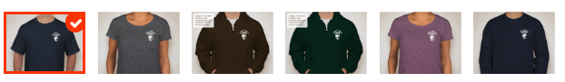
Buy a T-shirt ($20) or zippered hoodie sweatshirt ($35) to proudly display your support for the American Brittany Club Futurities. Order online
https://www.customink.com/fundraising/brittanyclubfundraiser2
Apparel Drive closes March 14, 2019
NOTE: There is a minimum of 10 items required to be purchased.

STANDARDS OF PERFORMANCE FOR THE ABC FUTURITIES

The ABC Futurities, Field and Show are run under the rules of the American Brittany Club Futurity Program and shall be judged on the Standard of Performance adopted by the ABC Board of Directors.

THE JUDGING OF THE ABC FIELD FUTURITY

ABC Futurity Field stakes (All-Age and Gun Dog) are run under the rules of the American Brittany Club Futurity Program and sanctioned by the American Field. There should be four money placements awarded in each stake. Braces should be 30 minutes, and it is at the judges’ discretion if a second series or callbacks are needed. Placements should be awarded to the “Best Dogs” in the stake. Finding birds on the course should be a primary objective, however as these field events are conducted under rules of the ABC Futurity, a placement without bird work on the course is permissible. The five minute out of judgment rule does not necessarily apply, and the judges are so advised. The decisions of the judges shall be final in all matters relating to the field trial performance of all the dogs.

ALL- AGE (Optional Horseback)
All-Age futurity dogs shall be judged as to their potential for developing into Champion All Age Brittanys. The All-Age dog is a free spirit and fills up all the available country (plus a little more) in a bold and sometimes reckless manner, yet ultimately acknowledges the control exerted by his handler and courses to the front in such a pattern as to maintain periodic suitable contact with the handler. The judges should examine the total performance of the dog with range being kept foremost in mind. Range is the essential ingredient of an All-Age dog and it should take precedence over and not be compromised for a shorter performance no matter how immaculate the bird work of the latter. The dog must respond to the handler but shall not be penalized for being more independent than an adult dog. A dog that handles at the extreme edges of the course shall be preferred over one that needs a scout to keep him on course, but both shall be preferred over a dog that does not have sufficient range for an All-Age dog. The All-Age dog shall hunt the forward limits of the course with intelligence, eagerness, and desire with the obvious intention of finding birds. When birds are located, the dog should point birds staunchly and with style. No extra credit shall be given for steadiness to wing and shot, but they shall be judged for their intelligence in finding and pointing birds in an unfinished All-Age manner.
GUN DOG (Foot Handled Only/Scout Optional Horseback)
Gun Dog futurity dogs shall be judged as to their potential for developing into Champion Gun Dog Brittanys. They shall exhibit a keen desire to hunt, a bold attractive style, intelligence in seeking objectives, eagerness and desire with the obvious intention of finding birds. When birds are located, the dog should point birds staunchly and with style. No extra credit shall be given for steadiness to wing and shot, but they shall be judged for their intelligence and consistency of application in finding and pointing birds in an unfinished Gun Dog manner, indicating their future potential as a high class Gun Dog. Throughout the brace, a Gun Dog

must adjust his pace and range to prevailing cover conditions. When the cover is heavy and tight, he will naturally hunt closer. When the cover "opens up" he should naturally adjust to the opportunity to hunt more distant, inviting objectives that may be productive. Natural adaptability is the mark of a superb bird dog, and excessive calling or hacking by the handler to accomplish satisfactory ranging - either closer or wider - is detracting from the dog's performance. The dog must cover adequate ground but should never range out of sight for a length of time that would detract from its usefulness as a class Gun Dog.

THE JUDGING OF THE ABC SHOW FUTURITY

Show classes shall be divided by sex, and there are three groups of classes: Senior (dogs whelped January - April), Intermediate (dogs whelped May - August), and Junior (dogs whelped September - December). There are 6 money placements awarded at the Futurity Show. The top 3 males and top 3 females are awarded First Money, Second Money, and Third Money in that order. First Money Male and First Money Female then compete for Best in Futurity and Best of Opposite Sex in Futurity. Equal consideration is to be given to each of the classes regarding money placements, and then for Best in Futurity and Best of Opposite in Futurity realizing that the more youthful dogs will be less mature and provided those points of immaturity are normal and appropriate for the breed at that time in development, they should not be penalized. Judges are not to anticipate what the dogs will look like in the future. Instead they are asked to judge the Futurity to the best of their ability, following the current published American Brittany breed standard, EXCEPT no dogs are to be measured at the Futurity Show. The judge should be instructed not to penalize dogs for being in field condition as many of the entries are entered in both the field and the show events. The decision of the judge is final in all matters pertaining to the show procedure and presentation of all dogs.

ABC FUTURITY DUAL AWARD

The dual futurity winner in each section will receive 5% of the gross purse for that section, divided 2/3 to the owner and 1/3 to the breeder. For a dog to be eligible for a sectional futurity Dual Dog Award, points must be won in both the show and the field futurity events, by defeating dogs. The point schedule is set by the ABC Board of Directors and found in the ABC Policy Book.

