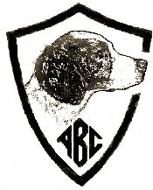
PREMIUM LIST
ABC Central Futurity
Sunday and Monday, March 10 - 11, 2019
Hosted by the Skyline Brittany Club

Dear Futurity Participant:
Enclosed please find the Central Section Entry Form(s) for your 2019 eligible futurity dog (s). This entry blank is being sent to you because of your 2017 breeder’s nomination and your final forfeit payment paid in 2018.
When completing your entry form, PLEASE PRINT CLEARLY.
Send your entry form and check, payable to the “American Brittany Club” to:
Dawn Craig, ABC Central Section Secretary
31515 County Road KK
Stratton, CO 80836
(970) 630-0956
EMAIL: dawn_craig@hotmail.com

CLOSING DATE: Wednesday February 20, 2019 at 5:00 PM (Central)
DRAWING DATE: February 26, 2019 at 7:00 PM (Central)

For those dogs eligible for the field, you must now make the determination whether to enter the All Age or Gun Dog stakes. You may not enter both. Performance standards for the field are on this premium. ENTRY FORMS AND PAYMENT ARE EXPECTED PRIOR TO THE CLOSE OF THIS EVENT.
Prize money will be paid to both the breeder and owner of record as identified on this entry blank. If you have sold your futurity nominated dog since paying the final forfeit last year, please pass this premium on to the new owner.
Information from the Skyline Brittany Club is also enclosed. Note directions & lodging info are also on this premium.
Good luck in the upcoming competition.
Sincerely,
Linda Langford
ABC Futurity Secretary
lalangford@hotmail.com
(205) 790-2133

ORDER OF EVENTS AND JUDGES

Sunday March 10, 2019 Futurity Show Event
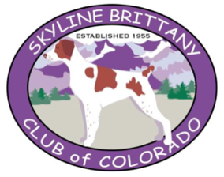
Judge: Kathleen Carter
Homestead Memorial Building
9550 CR DD
Idalia, CO 80735
Starts at 6:00 PM (CST)
Building available from 12 noon (CST)
BYOB Happy Hour to follow judging
Snacks provided by Skyline Brittany
Catered Lasagna Dinner will follow $18.50 (Prepaid)

Monday, March 11, 201 Futurity Field All Age Event, 8:00 AM
Judges: Eldon Hongo & Gary Fromme
Futurity Field Gun Dog Event will follow
Judges: Heather Gast & Eric Cook
If necessary, the Gun Dog will run on a 2nd course.
South Republican Wildlife Area and Hale Ponds
Burlington, CO
Catered Prime Rib Dinner will follow $25.00 (Prepaid)
at Homestead Memorial Building
Section Manager: Field Manager:
Leslee Masolotte Jeff Hoskins
leslee@windtuckfarm.com sniksohbritts@aol.com
(303) 868-9605 (303) 921-1077

American Brittany Club Officers Skyline Brittany Club Officers
www.theamericanbrittanyclub.org www.skylinebrittanyclub.com
Ed Janulis President Leslee Masolotte
Kent Patterson 1st Vice President Jeff Hoskins
Jeri Conklin 2nd Vice President Dawn Craig
Dawn Droel 3rd Vice President Lori Hugh
Bob Burchett 4th Vice President
Keith Wolnewitz Treasurer Jim Austin
Jan Kilpatrick Secretary Alice Janssen
7865 CR 271 1304 6th Street,
Hico, TX 76457 Fort Lupton, CO 80621
254-485-0844 720-857-7868
jankilabc@gmail.com starrlofts@q.com
Directors:
Dan Collins, Dave Klein, Barry Koepke
POINTS OF INTEREST
IN THE BURLINGTON, COLORADO AREA
OLD TOWN MUSEUM - 420 S. 14th St, Burlington, CO 80807 - 719-346-7382
KIT CARSON COUNTY CAROUSEL HISTORICAL LANDMARK –
KIT CARSON COUNTY FAIRGROUNDS
815 N 15th St, Burlington, CO - 719-346-7666 Open from Memorial Day to Labor Day unless by Private Reservation

DIRECTIONS TO TRIAL GROUNDS
Interstate 70 to Exit # 437 (Motel Exit) or #438 (Service exit) to Burlington. From Burlington go North on US Highway 385 (towards Wray) for 18.5 miles to Road O (Look for the Yuma County Sign). Go East on Road O, which becomes Road RR for 6 miles. The road turns north very sharply and becomes Road LL.5. Go North on LL.5 for 4.1 miles, past the South Republican River Wildlife Area signs to the Hale Ponds Parking Lot.

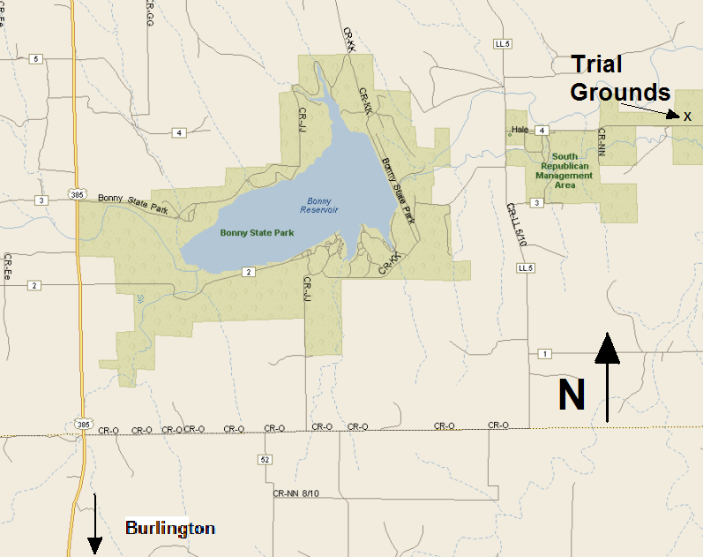

ROUTE TO EVENT HEADQUARTERS
FROM THE WEST - Take I-70 to Highway 385 (Exit 437), Turn left on to
US-385N/S Lincoln St., Hotel will be on your right
FROM THE EAST - Take I-70 to Highway 385 (Exit 437), Turn right on to
US-385N/S Lincoln St., Hotel will be on your right
ROUTE FROM EVENT HEADQUARTERS TO IDALIA HOMESTEAD MEMORIAL BUILDING
Head North (right turn from hotel) on US-385N/S Lincoln St to Rose Ave
Turn right on to Rose Ave for 1 mile
Turn left following US-385N/8th St continue straight for 27.8 miles
Turn left on to County Rd 9, continue straight onto US-36W for 1.7 miles
Turn right onto County Rd DD/Allen Ave
Homestead Memorial Building will be on the left
ROUTE FROM EVENT HEADQUARTERS TO FIELD TRIAL SITE
Head North on Highway 385 for 18.5 Miles, then east to the field trial grounds via Road O at the Yuma county sign. Follow directions to Hale Ponds.
ROUTE FROM FIELD TRIAL SITE to HOMESTEAD MEMORIAL BUILDING, IDALIA
From the field trial grounds at Hale Ponds just reverse the directions above back to Highway 385. Directions from the intersection of Road O and Highway 385 north to the intersection of Highway 385 and Highway 36 and then east to Idalia distance is about 9 miles.

Reminder: KANSAS is in the CENTRAL Time zone, 1 hour ahead of Colorado, which is in MOUNTAIN Time zone.

FUTURITY APPAREL
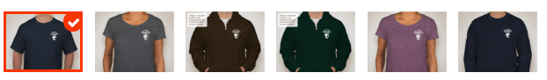
Buy a T-shirt ($20) or zippered hoodie sweatshirt ($35) to proudly display your support for the American Brittany Club Futurities. Order online
https://www.customink.com/fundraising/brittanyclubfundraiser

Skyline Brittany Club Specialty Show, Sunday March 10
from 12 noon to 4pm, prior to Futurity show judging. Same location!
Premiums available online….
https://www.championdogevents.com/skyline-brittany-club
For additional information, contact
Specialty Show Secretary - Sue Scott, Champion Dog Events
28485 Mid Jones Road
Calhan, CO 80808
(719) 338-0065 or chdogevents@aol.com
www.championdogevents.com

Skyline Brittany Club Field Trial, March 9, 10 and 12.
Contact Field Trial Secretary, Denise Collins, 2603 Del Sol Way, Parker, CO. 80138, dcollins@univair.com (303) 908-9042. Premiums for the trial will be available on www.fieldtrialnews.com and the American Brittany Club website: www.theamericanbrittanyclub.org located in the index of club premiums.
SHOW SITE INFORMATION
There is limited setup space. At the close of the show you may need to move dogs/crates to another area to ensure there is room to setup for the dinner.
The dog washing area will be a booster bath tub with cold water only and its outside on the north end of the building. It is recommended that those needing access to lots of electricity bring a generator. NO INSIDE GROOMING. No reserved grooming, and limited access to electricity.
No dogs are to be left in the building overnight.
RV’s are allowed to park during the day, but there is no RV camping overnight at the show site.
SPECIAL NOTICES
Dry climate, even at this time of the year, along with high altitude, can greatly affect you and your dogs. Please drink plenty of water and use sunscreen! Ensure dogs are drinking plenty of water as well. Even if days are cool and overcast, these tips are important.
Daylight Savings time is Sunday at 2:00 AM. Be prepared for the time change when planning your travel. We are SPRINGING FORWARD 1 HOUR, both in Colorado and Kansas.

NEARBY LODGING
QUALITY INN (EVENT HEADQUARTERS) - 282 S. LINCOLN ST, BURLINGTON, CO 80807 - 719-346-7676 - PET FRIENDLY, block of rooms reserved
Chaparral Motor Inn, 405 S Lincoln St, Burlington, CO 80807 - 719-346-5361
Fairfield Inn/Marriott - 526 S Lincoln St, Burlington, CO 80807 - 719-346-7094
Western Motor Inn - 222 Rose Ave, Burlington, CO 80807 - 719-346-5371
Best Western Plus Carousel - 605 S Lincoln St, Burlington CO 80807 719-346-7777
Homesteader Motel - Highway 36, St Francis KS 67756, (785) 332-2168 - 63.55 per night 2 people, includes tax, no pet fee, pets must be crated kept off furniture and not left unattended in the room.
When making reservations Please inquire about applicable Dog Fees and if any special rates for this event weekend. Because of carelessness of some exhibitors, show site, overnight parking and motel accommodations for clubs all over the USA are becoming more difficult to obtain and this location is no exception. Please cooperate by cleaning up after your dogs and kenneling your dog while in your motel room. There will be no bathing of dogs in the hotel room.
You are REQUIRED to clean up the area after walking your dogs at any hotel/motel. DO NOT leave dogs unattended inside any motel room or groom your dog inside any
CAMPING
RV Park – Outback RV Park located on 9th Street and Rose Ave, Burlington, CO 80807. (719) 346-7411
HORSES
No horses will be provided by the club.
PREPAID CATALOG SALES
The futurity catalog will be incorporated into the Specialty Show Catalog. In an effort to control costs, we are trying to prevent having a surplus of catalogs. We ask that you pre-purchase your catalog to ensure you get one, as the supply will be limited. Reserve your catalog using the attached worksheet, or go online at https://www.championdogevents.com/akc-online-entry-form

FIELD TRIAL GROUNDS INFORMATION
Please remember… we are guests of CDOW. These are public grounds and MUST be kept clean. Please clean-up after your dog, and fill any holes created by dogs or horses. STAKED OUT HORSES MUST BE MOVED DAILY. Make every effort to preserve the natural environment, including vegetation, soil, water and wildlife.
Only certified weed free grass hay may be fed on the State Wildlife grounds. Hay will available through the club for $16 per bale. Please indicate the number of bales you need when sending in your entries.
Space for boarding horses is available at the Kit Carson County Fairgrounds in Burlington. There is a $5 fee per horse each night, and you must clean out your stalls.

FOOD AND CONCESSIONS
Breakfast and lunch will be available from Dave’s Weiner Wagon at the Field Trial grounds on Sunday and Monday.
Concessions available (donations) at the Show site and there are limited options to obtain food at locations in Burlington and Idalia.
Saturday night Potluck.. Skyline is hosting a pot luck dinner on Saturday evening. The club will be providing Brisket and Ribs, tea and lemonade. Please bring your favorite per last name: A-G: Pasta or Veggie Salad, H-O: Side Dish and P-Z: Dessert.
Sunday Night Lasagna Dinner
At Homestead Memorial Building, Idalia, CO
w/salad, garlic bread and dessert, coffee/water/tea $18.50
Monday Night Prime Rib Dinner
At Homestead Memorial Building, Idalia, CO
w/potatoes, salad, roll, dessert, coffee/water/tea $25.00
Sunday and/or Monday meals must be prepaid!!
Please include note with your entry form and the additional funds
OR, You can include with online entry by picking that option and quantity of dinners in the Entry Store when entering (or without entering) https://www.championdogevents.com/akc-online-entry-form
BITCHES IN HEAT
Must be declared before the start of judging the field events and will be dropped to the bottom of the running order and either paired with a bitch or run as a bye dog if no open brace exists. If necessary, the Gun Dog will run on a 2nd course.

VETERNARIAN SERVICES

Republican Valley Vet Clinic
429 E Hwy 36
St Francis, KS 67756
(785) 332-2262

Vondy and Powell Vet Clinic – (719) 346-7341

EMERGENCY INFORMATION
EMERGENCY – 911
Burlington Police (non-emergency) – (719) 346-8353
Ambulance (non-emergency) – (719) 346-5678
Emergency Management Agency (Toxic Waste, Weather, Environmental) – (719) 346-8353
Kit Carson County Memorial Hospital
286 16th Street
Burlington, CO
(719) 346-5311
Colorado Road Conditions – 1 (877) 315-7623
In case of injury requiring medical attention, all incidents must be reported to a Futurity Committee member, the Central Futurity Section Manager and Colorado Parks and Wildlife at (970) 354-7317.
TROPHY DONATIONS
Donations are accepted and greatly appreciated towards the 2019
Futurity Trophy Fund. Contact Linda Langford – ABC Futurity Secretary at lalangford@hotmail.com or (205) 790-2133 for more information.

You can donate online at: http://clubs.akc.org/brit/FuturityTrophyDonation.html
Club:  American Brittany Club |  |  | Event #:  2017/2019 Central Futurity
Location:  Show: Homestead Memorial Building,  Idalia, CO  Field: So Republican River Wildlife  Area, Burlington, CO |  |  | Date(s):  March 10-11, 2019 |  |  |  |  |  | Event type:  Central Futurity
Enter in Field Futurity $60.00  (NOTE: Select only ONE option):  All-Age Gun Dog |  |  |  |  |  | Enter in Show Futurity $40.00:  Show
AKC # OTHER |  | FDSB # |  |  |  |  |  | I enclose entry fees in the amount of:
Full Name of Dog:

Call Name: | Date of Birth: |  |  |  | Sex: |  | Color: |  | AKC DNA (optional)
Sire:

Dam:

Name of Breeder (s):

Field Handler (if applicable)
Show Handler (if applicable)
Actual Owner(s):

Owner’s Address:

City: |  |  |  | State: |  |  |  | Zip:
Signature of owner or his agent duly authorized to make this entry:
Telephone:

Email address:
CATALOG ADS
Ads are being accepted for the catalog. All ads must be in Jpeg format, otherwise they will be scanned, and quality may be lost. Each advertiser will receive a FREE CATALOG. Ad Deadline is February 20, 2019

Full Page 7 ½” x 4 ½” (including one photo) $30.00
Half Page with one photo $20.00
Quarter Page (no photo) $15.00
Inside Front or Back Cover $35.00
Back Cover $40.00
Business Card $ 5.00
Memorial Listing $ 1.00
This is two lines of text stating: In Memory of …(dog) by (owner).
Kennel Listing $ 3.00
This is 3 lines of text stating: Kennel Name, address, phone & email

Send Ads and Fees to Specialty Show Secretary: Champion Dog Events, 28485 Mid Jones Rd, Calhan, CO 80808

Futurity Fee Worksheet ____________________ (name)
All- Age Futurity $60 x______ # Dogs = $___________.00
Gun-Dog Futurity $60 x______ # Dogs = $___________.00
Show Futurity $40 x______ # Dogs = $___________.00
Weed Free Hay $16 x______ # Bales = $___________.00
Pre-Paid Catalogs $ 5 x______ # Catalogs = $___________.00
Sunday Dinner $18.25 x______ # People = $______________
Monday Dinner $25.00 x______ # People = $___________.00

Total
Checks Payable to: ABC $_____________
STANDARDS OF PERFORMANCE FOR THE ABC FUTURITIES

The ABC Futurities, Field and Show are run under the rules of the American Brittany Club Futurity Program and shall be judged on the Standard of Performance adopted by the ABC Board of Directors.

THE JUDGING OF THE ABC FIELD FUTURITY

ABC Futurity Field stakes (All-Age and Gun Dog) are run under the rules of the American Brittany Club Futurity Program and sanctioned by the American Field. There should be four money placements awarded in each stake. Braces should be 30 minutes, and it is at the judges’ discretion if a second series or callbacks are needed. Placements should be awarded to the “Best Dogs” in the stake. Finding birds on the course should be a primary objective, however as these field events are conducted under rules of the ABC Futurity, a placement without bird work on the course is permissible. The five minute out of judgment rule does not necessarily apply, and the judges are so advised. The decisions of the judges shall be final in all matters relating to the field trial performance of all the dogs.

ALL- AGE (Optional Horseback)
All-Age futurity dogs shall be judged as to their potential for developing into Champion All Age Brittanys. The All-Age dog is a free spirit and fills up all the available country (plus a little more) in a bold and sometimes reckless manner, yet ultimately acknowledges the control exerted by his handler and courses to the front in such a pattern as to maintain periodic suitable contact with the handler. The judges should examine the total performance of the dog with range being kept foremost in mind. Range is the essential ingredient of an All-Age dog and it should take precedence over and not be compromised for a shorter performance no matter how immaculate the bird work of the latter. The dog must respond to the handler but shall not be penalized for being more independent than an adult dog. A dog that handles at the extreme edges of the course shall be preferred over one that needs a scout to keep him on course, but both shall be preferred over a dog that does not have sufficient range for an All-Age dog. The All-Age dog shall hunt the forward limits of the course with intelligence, eagerness, and desire with the obvious intention of finding birds. When birds are located, the dog should point birds staunchly and with style. No extra credit shall be given for steadiness to wing and shot, but they shall be judged for their intelligence in finding and pointing birds in an unfinished All-Age manner.
GUN DOG (Foot Handled Only/Scout Optional Horseback)
Gun Dog futurity dogs shall be judged as to their potential for developing into Champion Gun Dog Brittanys. They shall exhibit a keen desire to hunt, a bold attractive style, intelligence in seeking objectives, eagerness and desire with the obvious intention of finding birds. When birds are located, the dog should point birds staunchly and with style. No extra credit shall be given for steadiness to wing and shot, but they shall be judged for their intelligence and consistency of application in finding and pointing birds in an unfinished Gun Dog manner, indicating their future potential as a high class Gun Dog. Throughout the brace, a Gun Dog

must adjust his pace and range to prevailing cover conditions. When the cover is heavy and tight, he will naturally hunt closer. When the cover "opens up" he should naturally adjust to the opportunity to hunt more distant, inviting objectives that may be productive. Natural adaptability is the mark of a superb bird dog, and excessive calling or hacking by the handler to accomplish satisfactory ranging - either closer or wider - is detracting from the dog's performance. The dog must cover adequate ground but should never range out of sight for a length of time that would detract from its usefulness as a class Gun Dog.

THE JUDGING OF THE ABC SHOW FUTURITY

Show classes shall be divided by sex, and there are three groups of classes: Senior (dogs whelped January - April), Intermediate (dogs whelped May - August), and Junior (dogs whelped September - December). There are 6 money placements awarded at the Futurity Show. The top 3 males and top 3 females are awarded First Money, Second Money, and Third Money in that order. First Money Male and First Money Female then compete for Best in Futurity and Best of Opposite Sex in Futurity. Equal consideration is to be given to each of the classes regarding money placements, and then for Best in Futurity and Best of Opposite in Futurity realizing that the more youthful dogs will be less mature and provided those points of immaturity are normal and appropriate for the breed at that time in development, they should not be penalized. Judges are not to anticipate what the dogs will look like in the future. Instead they are asked to judge the Futurity to the best of their ability, following the current published American Brittany breed standard, EXCEPT no dogs are to be measured at the Futurity Show. The judge should be instructed not to penalize dogs for being in field condition as many of the entries are entered in both the field and the show events. The decision of the judge is final in all matters pertaining to the show procedure and presentation of all dogs.

ABC FUTURITY DUAL AWARD

The dual futurity winner in each section will receive 5% of the gross purse for that section, divided 2/3 to the owner and 1/3 to the breeder. For a dog to be eligible for a sectional futurity Dual Dog Award, points must be won in both the show and the field futurity events, by defeating dogs. The point schedule is set by the ABC Board of Directors and found in the ABC Policy Book.

