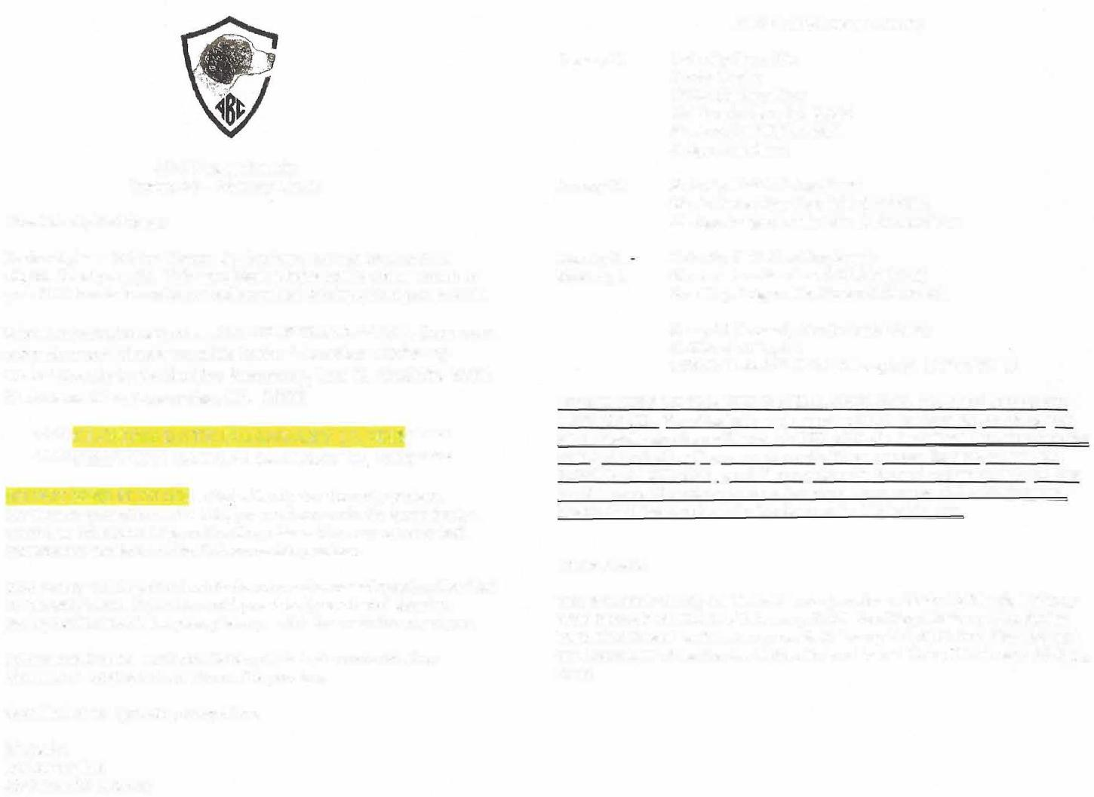
ABC 2018 Western Futurity
January 30
Futurity Show Site
Strata Center
10350 Heather Place California City, CA 93504 Starts at 1:00 P.M. (PST) Judge: Ann Short
January 31
Futurity Field All Age Event
Starts Not earlier than 8:00 AM (PST)
All Age Judges: Leslie Like & Michael Vaz
January 31
Futurity Field Gun Dog Event
Starts not earlier than 7:30 AM (PST)
Gun Dog Judges: Jim House & Steve Ball
Camp H (formerly Castle Butte Wells)
California City, CA
GPS: Latitude 3 5° 11' 34" N Longitude 117° 42' 30" W
DIRECTIONS TO THE FIELD TRIAL GROUNDS- MAP INCLUDED ON THIS EMAIL. (See attached map) - once on 20 Mule Team Rd, continue past Silver Saddle sign turn off, down to TULANE. On the left will be 3 tires stacked on top of each other (2 green and a red). When you see the tires, turn to the RIGHT onto TULANE, go all the way down to the end and on the left you will see the camp. We will try to have American Flags on the TULANE sign post. People steal them, so look for the tires on the left just in case.
Other Events
The Western Futurity will be held in conjunction with the California Brittany Club Spring Field Trial held January 27-29. San Diego Brittany Club Spring Field Trial is held on the same grounds February 3-4, 2018. San Diego BC and California BC will host a double/double hunt test at Camp H February 10 & 11, 2018.
ABC Western Futurity January 30 -January 31, 2018
Dear Futurity Participant:
Enclosed please find the Western Section Entry Form(s) for your 2018 eligible futurity dog (s). This entry blank is being sent to you as a result of your 2016 breeder's nomination and your final forfeit payment paid in 2017.
When completing the entry form, PLEASE PRINT CLEARLY. Send your entry form and check payable to the "American Brittany Club" directly to the Section Secretary, Jeri K. Conklin- 8756 W Avenue C14, Lancaster, CA 93536
****CLOSING DATE IS JANUARY 12, 2018***** ****DRAWING DATE IS JANUARY 17, 2018****
DO NOT SEND IT TO ME as that will only slow the entry process.
For those dogs eligible for the field, you must now make the determination whether to enter the All Age or Gun Dog stakes. You may not enter both. Performance standards for the field are on this premium.
Prize money will be paid to both the breeder and owner of record as identified on this entry blank. If you have sold your futurity nominated dog since paying the final forfeit last year, please pass this form onto the new owner.
Information from the California Brittany Club is also enclosed. Note directions & lodging info are also on this premium.
Good luck in the upcoming competition.
Sincerely,
Linda Langford
ABC Futurity Secretary

x ____ (#of persons) =$ ________________
DAY OF SHOW - Tuesday, January 30, 2018
Lunch
Catered Dinner
DAY OF SHOW - Tuesday, January 30, 2018
Lunch
Catered Dinner
Please return this form with your entry, with a separate check made payable to:
California Brittany Club.
Day of Show Lunch Only - $5.00
Package - 2 Lunches and 2 Dinners - $20 (p/prsn) NAME
Please check those boxes of the meals you will be attending.
Breakfast is complimentary each morning on the field trial grounds at Camp H
FDSB#
AKC# Other
I enclosed entry fees in the amount of:
Enter in Show Futurity $40.00:

SHOW
Enter in Field Futurity: $60.00
(Note, Select only ONE option)
ALL-AGE GUN DOG
Event Type:
Western Futurity
Date:
January 30-31, 2018
Club: Event#:
American Brittany Club 2016/2018 Western Futurity
Location:
Show: Strata Center
California City, CA
Field: Camp H
California City, CA

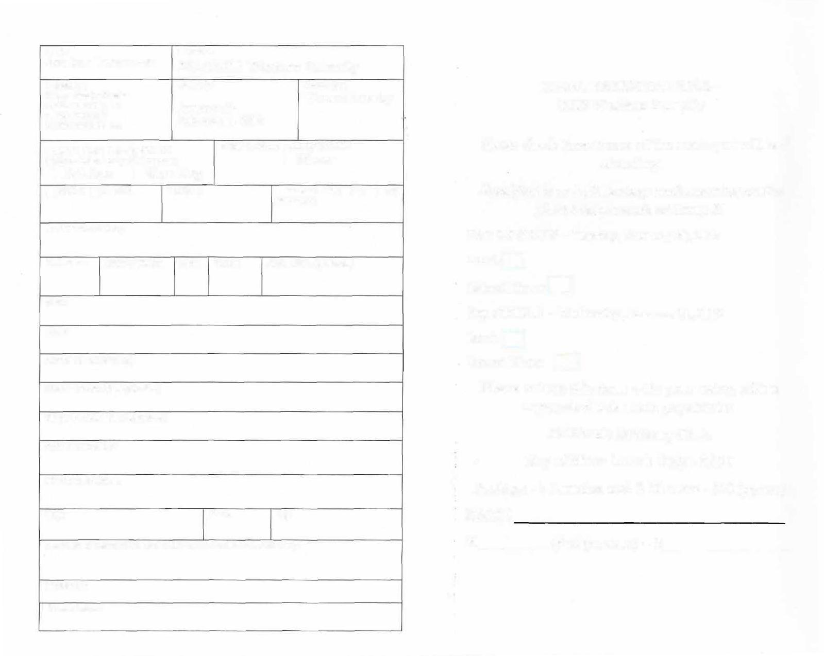
MEAL RESERVATIONS-2018 Western Futurity
Full Name of Dog:
Call Name: Date of Birth: Sex: Color: AKC DNA (optional)
Sire:
Dam:
Name of Breeder (s):
Field Handler (if applicable)
Show Handler (if applicable)
Actual 0wner(s):
Owner's Address:
City: State: Zip:
Signature of owner or his agent duly authorized to make this entry:
Telephone:
Email address:

Questions or needing any additional information, please don't hesitate to contact us.
Section Manager: Linda McDonald (760) 956-8943
mcbritbull@gmail.com
Section Secretary: Jeri K. Conklin- 8756 W Avenue Cl4 Lancaster, CA 93536 (661)728-0969 or Cell phone (817-771-7707 jericonklin@yahoo.com
Food:
Continental breakfast at the field trial grounds is complimentary.
Food - $20 buys you two lunches (Show/Field days) and two dinners (catered Tuesday night and Wednesday night). It is a packaged deal. Day of show lunch only - $5. Reservation and check made payable to California Brittany Club must accompany your entry form.
The California Brittany Club is offering an Amateur Walking Derby (Brittany only) stake as well as Open Derby during their regular field trial preceding the Futurity. Dogs that have aged out of the derby stakes will also be provided an opportunity on the grounds. Please contact Jeri Conklin for more information.
*** TROPHY DONATIONS***
Donations are accepted and greatly appreciated towards the 2018
Futurity Trophy Fund. Contact Linda Langford -ABC Futurity Secretary at
lalangford@hotmail.com or (205) 790-2133 for more information.
***CATALOG***
Ads are being accepted for the catalog. Page size is 5 1/2 x 8 1/2. Ads must be camera ready, or we will set so long as your picture and ad information is provided. Please send money and ad information to: Jeri Conklin, 8756 W Avenue Cl 4, Lancaster, CA 93536. Checks made payable to: California Brittany Club.
Full page color ad: $20.00 -must be camera ready or ready to set-up
Deadline for ads is: January 13, 2018. Please contact Jeri Conklin for more information on ads at jericonklin@yahoo.com.
STANDARDS OF PERFORMANCE FOR THE ABC FUTURITIES
The ABC Futurities, Field and Show are run under the rules of the American Brittany Club Futurity
Program, and shall be judged on the Standard of Performance adopted by the ABC Board of Directors.
THEJUDGTNG OF THE ABC FIELD FUTURITY
ABC Futurity Field stakes (All-Age and Gun Dog) are run under the rules of the American Brittany Club Futurity Program and sanctioned by the American Field. There should be four money placements awarded in each stake. Braces should be 30 minutes, and it is at the judges' discretion if a second series or callbacks are needed. Placements should be awarded to the "Best Dogs" in the stake. Finding birds on the course should be a primary objective, however as these field events are conducted under rules of the ABC Futurity, a placement without bird work on the course is permissible. The five minute out of judgment rule does not, and the judges are so advised. The decisions of the judges shall be final in all matters relating to the field trial performance of all the dogs.
ALL- AGE (Optional Horseback)
All-Age futurity dogs shall be judged as to their potential for developing into Champion All Age Brittanys. The All-Age dog is a free spirit and fills up all the available country (plus a little more) in a bold and sometimes reckless manner, yet ultimately acknowledges the control exerted by his handler and courses to the front in such a pattern as to maintain periodic suitable contact with the handler. The judges should examine the total performance of the dog with range being kept foremost in mind. Range is the essential ingredient of an All-Age dog and it should take precedence over and not be compromised for a shorter performance no matter how immaculate the bird work of the latter. The dog must respond to the handler but shall not be penalized for being more independent than an adult dog. A dog that handles at the extreme edges of the course shall be preferred over one that needs a scout to keep him on course, but both shall be preferred over a dog that does not have sufficient range for an All-Age dog. The All-Age dog shall hunt the forward limits of the course with intelligence, eagerness, and desire with the obvious intention of finding birds. When birds are located, the dog should point birds staunchly and with style. No extra credit shall be given for steadiness to wing and shot, but they shall be judged for their intelligence in finding and pointing birds in an unfinished All-Age manner.
GUN DOG (Foot Handled Only/Scout Optional Horseback)
Gun Dog futurity dogs shall be judged as to their potential for developing into Champion Gun Dog Brittanys. They shall exhibit a keen desire to hunt, a bold attractive style, intelligence in seeking objectives, eagerness and desire with the obvious intention of finding birds. When birds are located, the dog should point birds staunchly and with style. No extra credit shall be given for steadiness to wing and shot, but they shall be judged for their intelligence and consistency of application in finding and pointing birds in an unfinished Gun Dog manner, indicating their future potential as a high class Gun Dog. Throughout the brace, a Gun Dog must adjust his pace and range to prevailing cover conditions. When the cover is heavy and tight, he will naturally hunt closer. When the cover "opens up" he should naturally adjust lo the opportunity to hunt more distant, inviting objectives that may be productive, Natural adaptability is the mark of a superb bird dog, and excessive calling or hacking by the handler to accomplish satisfactory ranging - either closer or wider - is detracting from the dog's performance. The dog must cover adequate ground but should never range out of sight for a length of time that would detract from its usefulness as a class Gun Dog.
THE JUDGING OF THE ABC SHOW FUTURITY
Show classes shall be divided by sex, and there are three groups of classes: Senior (dogs whelped January - April), Intermediate (dogs whelped May - August), and Junior (dogs whelped September - December). There are 6 money placements awarded at the Futurity Show. The top 3 males and top 3 females are awarded First Money, Second Money, and Third Money in that order. First Money Male and First Money Fern ale then compete for Best in Futurity and Best of Opposite Sex in Futurity. Equal consideration is to be given lo each of the classes regarding money placements, and then

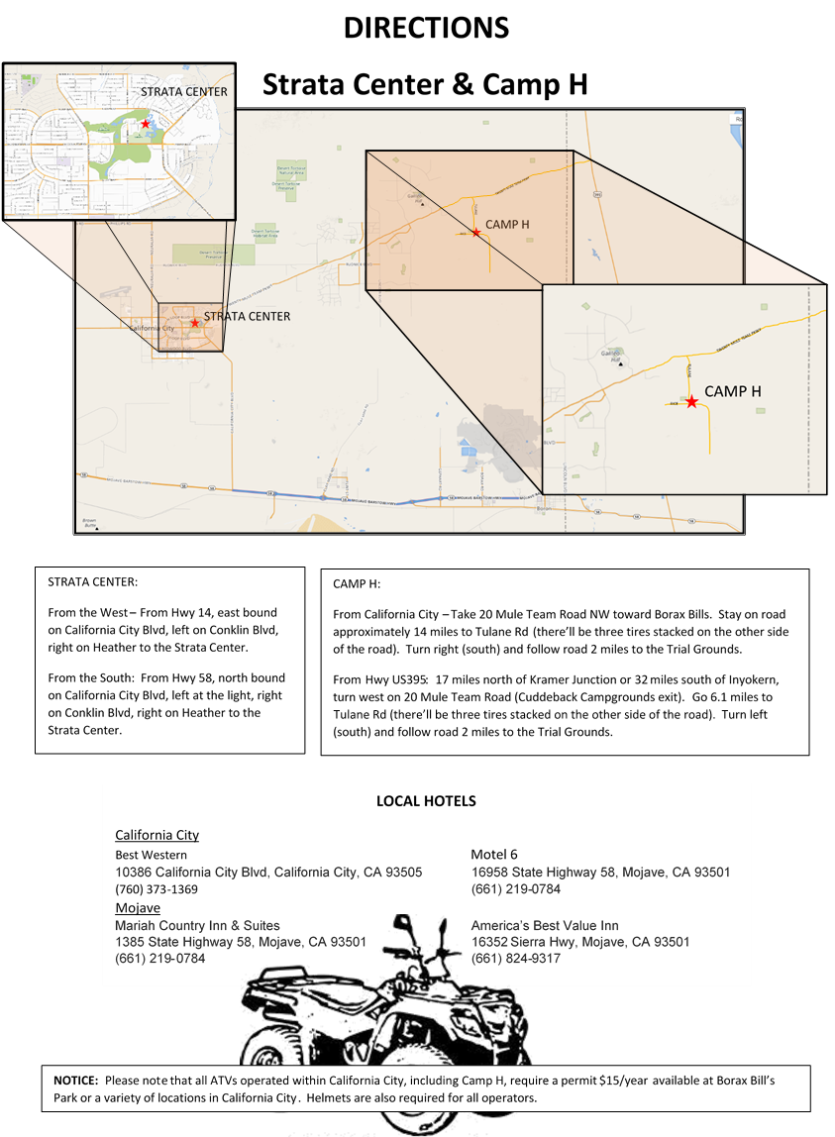

for Best in Futurity and Best of Opposite in Futurity realizing that the more youthful dogs will be less mature, and provided those points of immaturity are normal and appropriate for the breed at that time in development, they should not be penalized. Judges are not to anticipate what the dogs will look like in the future. Instead they are asked to judge the Futurity to the best of their ability, following the current published American Brittany breed standard, EXCEPT no dogs are to be measured at the Futurity Show. The judge should be instructed not to penalize dogs for being in field condition as many of the entries are entered in both the field and the show events. The decision of the judge is final in all matters pertaining to the show procedure and presentation of all dogs.
The dual futurity winner in each section will receive 5% of the gross purse for that section, divided 2/3 to the owner and 1/3 to the breeder. For a dog to be eligible for a sectional futurity Dual Dog Award, points must be won in both the show and the field futurity events, by defeating dogs. The point schedule is set by the ABC Board of Directors and found in the ABC Policy Book.
ABC FUTURITY DUAL AW ARD

